Sequencing Homework 2
Name: |  | Class:
Task 1: Look at the following maze. Write a series of instructions to tell somebody how to move through the maze from A to B. You can only use commands such as “forward 5” (to move forward 5 spaces), “turn left” or “turn right”.
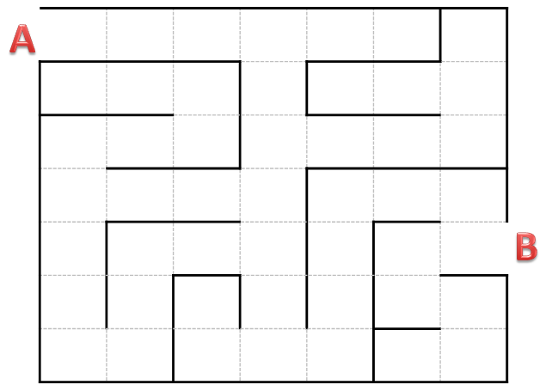
Write your instructions below

Extension Activity: Use the space on the back of this sheet to create your own maze and then write instructions for how to get through it.

