Product Development Life Cycle
Name: |  | Class:
Task 1: Look at the diagram showing the product development life cycle.
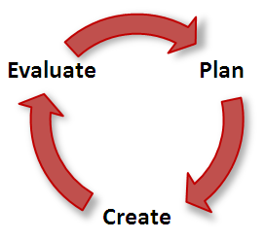
Describe the sorts of things you did in each of these stages during this project.
Stage | What happens in this stage
Plan
Create
Evaluate

Extension Activity: Explain why the product development life cycle never ends.

