Melland High School Curriculum Policy

- Basic principles
  - Our curriculum is designed to secure, in students’ long-term memory, an ambitious body of developmentally appropriate essential knowledge for both academic and personal development.

  - We recognise that it takes a long time for long-term memory to develop, and that repetition and a carefully sequenced curriculum is required in order for it to do so.

  - Learning episodes are always appropriate and, over time, varied with the aim of building strong schemata in students’ long-term memory. Within one lesson the episodes may look different for each student, appropriate to their individual needs.

- Breadth of study (content)
  - Our curriculum meets the requirements for a broad and balanced curriculum:
    - it has Spiritual, Moral, Social and Cultural development at its heart;
    - it prepares students for the next stages of education and for life in modern Britain;
    - it is coherently planned;
    - it is published on our website, for all stakeholders to view.

  - In addition to being broad and balanced, our curriculum meets the requirement to provide a basic curriculum:
    - a daily act of collective worship is undertaken in a variety of forms;
    - a well-planned personal development programme, that includes age-appropriate sex and relationships education, is in place.
    - a well-planned programme for Religious Education is in place.

  - Based on the aims of the National Curriculum and early years requirements, our curriculum offers students an introduction to the best that has been thought and said, giving them the powerful subject knowledge that gives pupils academic and intellectual ways of thinking, and powerful personal knowledge that gives them the character, dispositions, attitudes and habits to navigate their way through life and the cultural capital that they need to be successful citizens.

  - In order to meet the needs of our students our breadth of study is driven by five curriculum drivers:

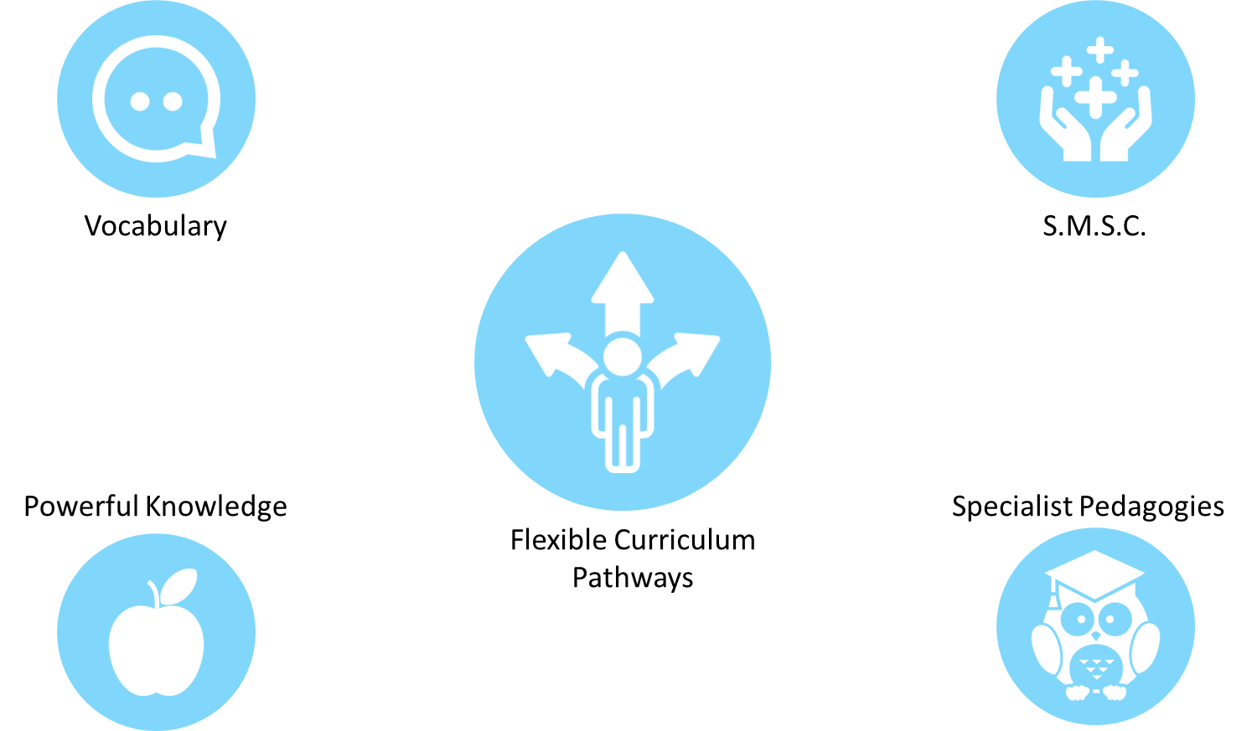

    - flexible curriculum pathways (pre-formal, semi-formal and formal)
At Melland we have Flexible Curriculum Pathways. These pathways at their core are the Pre-formal, Semi-formal and Formal pathways. Each of these core pathways are ambitious, carefully sequenced, well-considered and progressive.
Each pathway has its own curriculum but they are part of a greater learning continuum with each student getting a personalised curriculum to meet their academic and personal development needs. There are some shared aspects, for example, Skills for Life, careers education, SMSC, Fundamental British Values, personal safety, health education and Preparation for Adulthood.
Students can move between the pathways or experience elements of more than one.
    - spiritual, moral, social and cultural development (SMSC)
Students and their well-being are at the core of our school curriculum.
Having SMSC as a driver allows us to bring into focus how our curriculum helps encourage our students to become successful learners, confident individuals and responsible citizens and ensures we do not lose sight of it.
Our overarching ethos for SMSC encompasses personal development across the whole curriculum and supports us in providing opportunities for students to explore themselves and discover their identity. Additionally, it equips them with strong values for living in an increasingly diverse world.
    - powerful knowledge (giving students the essential knowledge and cultural capital they need to be successful citizens)
Powerful knowledge refers to the essential knowledge and cultural capital that students may not typically acquire from everyday life. It requires expert teaching and explicit content delivery to prepare students for adulthood and life beyond education. It introduces them to the best that has been thought and said and will help engender an appreciation of human creativity and achievement. Students acquire bespoke and targeted powerful knowledge based on their pathway or personalised curriculum.
    - specialist pedagogies
We use research and training to ensure our staff are equipped with specialist pedogeological knowledge to meet the needs of all our students. All staff understand the needs of students with SEND and they use informed specialist methodologies to deliver accessible and aspirational learning opportunities for all. The specialist pedagogies required can be different depending on the Key Stage, pathway or subject.
    - Vocabulary
Vocabulary is important as it helps shape our thinking. The explicit teaching of vocabulary is essential for our students as they may not acquire vocabulary incidentally through indirect exposure.
All our students benefit from developing their vocabulary. Our curriculum strikes an appropriate balance between functional vocabulary and enriching vocabulary. The development of vocabulary is not restricted to academic development but also enriches personal development.

  - Each curriculum pathway has its own balance of personal and academic content that is appropriate to the needs of students.

  - Within each subject, content is carefully sequenced around Threshold Concepts or Key Concepts which form the basis for schema development: area of content references the prior knowledge gained in previous area of content, thus building a solid understanding of how it relates. Areas of content, therefore, are not seen as stand-alone units of learning but as a further development of a strong subject schema.

- Progression
    - Our curriculum is based on flexible curriculum pathways comprising:
    - Developmental Milestones
    - Academic Milestones

  - All students are given ambitious and developmentally appropriate learning goals taken from the Milestones.

  - Progression is seen as:
    - Retaining specific knowledge in relation to the Milestones
    - Relating new to prior knowledge.

  - For this reason, threshold concepts and key concepts are established, which form the basis for relating new knowledge to prior knowledge. In doing so, students develop meaningful procedural and semantic knowledge.

- Implementation
  - We understand that knowledge can be easily forgotten once an area of content is completed. To mitigate the likelihood of forgetting we:
    - Have planned repetition and retrieval across lots of different contexts (yesterday, earlier in the day, last week and different environment)
    - Reference new knowledge with prior knowledge which provides opportunity for recall.
    - When appropriate use repetition and retrieval practice in a number of ways:
      - Repetition and/or retrieval from previous year groups;
      - Repetition and/or retrieval from previous topics;
      - Repetition and/or retrieval from previous lessons;
      - Repetition and/or retrieval from earlier in a lesson.

  - Knowledge is organised to provide students with an overview of the essential knowledge on the basis of a schema. Lessons are designed so students understand this knowledge.

  - Systematic modelling forms the basis for the vast majority of teaching. We follow Rosenshine’s principles of instruction, in particular:
    - Step-by step modelling
    - Frequent re-visiting
    - Frequent questioning
    - High success rate for students.

  - Deliberate practice towards the milestones gives teachers evidence of learning.
High quality evidence of students progress shows the essential knowledge they have been taught in each lesson.

  - Our curriculum is driven by specialist pedagogies and so, across the flexible curriculum pathways, teachers and support staff employ research-based techniques appropriate to the individual needs of students. We are embarking on further research into pedagogical content knowledge to help us develop teacher expertise in this area.

  - Spiritual, moral, social and cultural development is embedded in all aspects of personal and subject-specific development.

  - Rich, varied and ambitious vocabulary forms the basis for the articulation (verbal and written) across all areas of learning.

  - Our lessons are taught using appropriate and varied research-based methods that reflect the powerful knowledge students should learn (For example, in the formal geography curriculum students write factual sentences about the physical processes involved in plate tectonics rather than make models of volcanoes.)

- Impact
  - Monitoring
    - Senior leaders monitor whether the intended curriculum is enacted by assessing:
      - the extent to which the curriculum is implemented as planned;
      - through direct observation, the extent to which teaching reflects our stated approaches. (see section 4, above)

    - The curriculum team and heads of department monitor the effectiveness of the implemented curriculum by assessing:
      - the expertise of teachers in implementing the curriculum, providing support and training where necessary (lesson observations)
      - the students’ deliberate practice towards their milestones and the quality of evidence recorded by staff and/or students’ work.
      - the extent to which students are remembering and knowing more as they progress through the curriculum (discussions with students)

    - Subject coordinators provide information to senior leaders about 5.1 and 5.2, above. In addition they are supported in conducting a deep dive into their subject so they can see the strengths and areas for improvement in curriculum design. They produce subject evaluation for senior leaders based on their findings.

  - Assessment
    - Our approach to assessment is:
      - Assessment is based upon progression towards our curriculum end points (see section 4)
        - in the short term assessment for learning through class teaching, questioning and retrieval practice gives valuable practice towards the stated curriculum end points. In addition to this, teachers gain valuable insights that highlight the need for interventions. This is not formally recorded.
        - in the medium-term, termly formative assessments including multiagency and therapeutic reports give insights to teachers that allow them to make well-founded decisions as to the next steps for students. All assessments of this nature are recorded and tracked so that they can be used to later evaluate the teacher’s response to the assessments. Interventions are planned for those not making expected progress.
        - in the long-term, end of year assessments give us valuable insights about students’ long-term retention of essential knowledge. This also informs end of year reports for parents/carers and the evaluation ECHP outcomes.

    - Teacher workload in relation to the benefit the work is to students is foremost in our mind when making assessment arrangements; arrangements have been stripped back to only the most useful and informative.

